*Mission Operations Overview*

Saint Louis University

Rascal



Last Updated: 4/7/14

Document No: RCL-O-MOP1

|  |  |  |  |
| --- | --- | --- | --- |
| Prepared by: |  |  |  |
|  | Nate Richard  Rascal Mission Operations Subsystem Insert Subystem Position Here |  | Date |
| Approval: |  |  |  |
|  | Dr. Michael Swartwout  Rascal Principal Investigator |  | Date |

**Revisions Summary**

|  |  |  |  |  |
| --- | --- | --- | --- | --- |
| Revision | Description | Date | Prepared by | Approved by |
| - | Initial Release | 4/6/2014 | Nate Richard | Tom Moline |
|  |  |  |  |  |
|  |  |  |  |  |
|  |  |  |  |  |
|  |  |  |  |  |
|  |  |  |  |  |

Contents

1. The Ground Station 4

1.1. Ground Station Hardware 4

1.2. Ground Station Software 4

2. Operator Interface 4

3. Payload Troubleshooting 6

# The Ground Station

The ground station serves as the means to verify the completion of each mission goal. It will also serve to troubleshoot any problems that arise during the mission. The command to power on and off the visual aids will originate from the ground station as well.

## Ground Station Hardware

The hardware of the ground station consists of a radio, an antenna, an external TNC, and a means to control the antennas. They are described in detail below:

* **Radio:** It is a Kenwood TS-2000 radio. The radio operates on the VHF 144 MHz band and the UHF 430-440 MHz band. The transmit power is 50 W.
* **Antenna:** The antenna is a dual band Yagi antenna. There is a 70 cm antenna and a 2 m antenna.
* **External TNC:** The external TNC is a Kantronics 9612+. It is capable of handling GMSK and FSK modulated signals on the AX.25 protocol.
* **Rotor Control:** A G-5500 Yaesu controller controls the antenna azimuth and elevation motors. It is capable of traveling 180° in the elevation direction and 450° in the azimuth direction.
* **Computer Controller:** The computer interfaces with the rotor controller via the Yaesu GS-232B Computer Controller.

## Ground Station Software

There are three programs used for the ground station to track and command a satellite. They are described in detail below:

* **Orbitron:** Orbitron tracks the spacecraft and determines its azimuth and elevation. It also calculates the Doppler Shift necessary to maintain contact with the spacecraft.
* **WispDDE:** WispDDE sends the commands to the rotor control to move the antenna and to the radio to account for Doppler Shift.
* **Ground Station Software:** The ground station software was written in house and it is responsible for sending commands to the spacecraft.

# Operator Interface

The Ground Station software serves as the primary interface between the ground station and the satellite. It is where commands originate and telemetry data is decoded. It was designed to be user friendly where commands could be sent with the click of a button, beacon packets are automatically decoded as they are received, and the beacon data is displayed. If it is required, commands can be sent manually sent through it. The software can be quickly reconfigured to account for changes in the hardware setup.

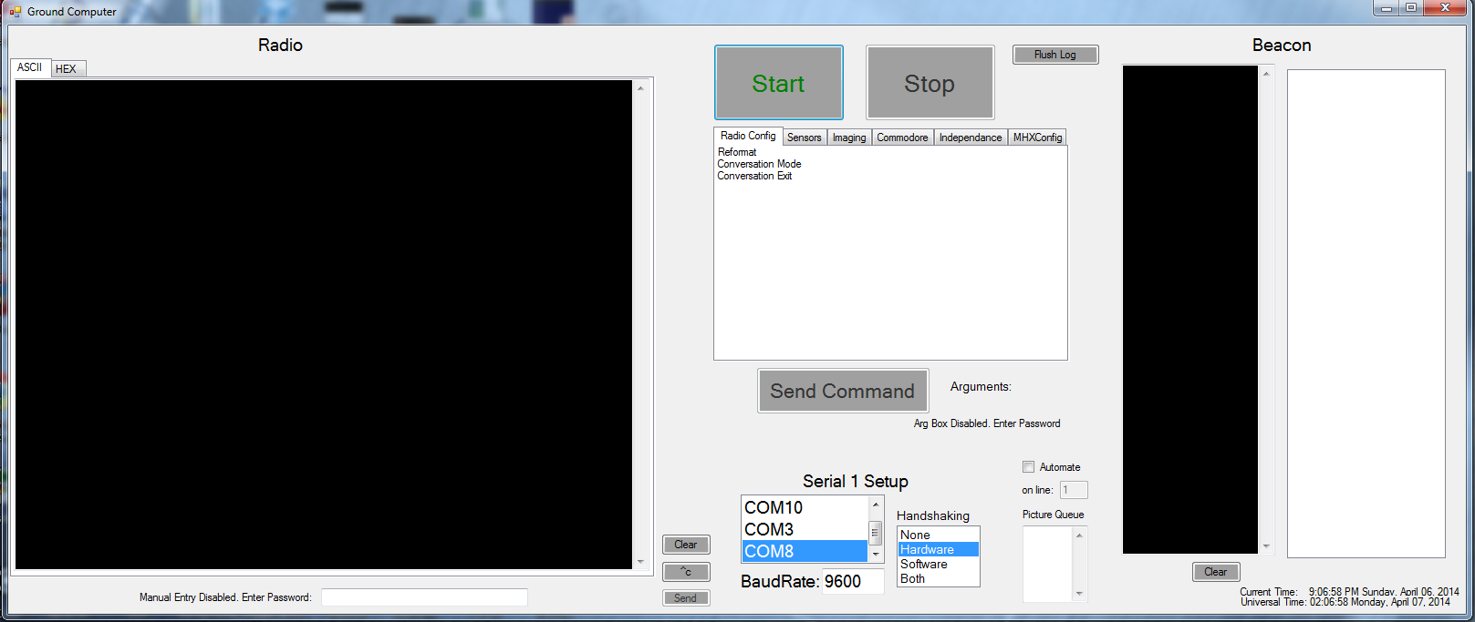

**Figure 1:** Ground Station Software

**1**

**2**

**3**

**4**

**5**

**6**

**7**

**8**

**9**

1. This configures how the software interfaces with the hardware. The port the TNC is on is selected; the type of handshaking that occurs between the software and device, and the baud rate the communication takes place.
2. This starts communication over the port selected in number one. When the stop button is click, it will flush a log of the beacon data and the event data.
3. This is where the commands are selected. There are commands to reconfigure the TNC in addition to the commands for the spacecraft. The command is selected and then the button "Send Command" is clicked. In order to reduce operator error all the commands are buttons.
4. This is the event window where all the raw beacon data appears as well as any responses to commands. There are to tabs, one to view the data in ASCII and another to view it in hex.
5. The beacon data automatically appears here when it is received. The raw data appears on the left, and then the hex data is interpreted and displayed on the right.
6. This where commands can be sent manually. A password is required before commands can be entered. The reason for having a manual method of sending commands is to send commands that would not be sent during normal operations or to test out new commands not yet implemented.
7. This button flushes the beacon. If the beacon and/or event log is needed before the current satellite pass ends, those logs can be created while the software is still running.
8. If a large amount of picture data is needed, number eight will automatically send a command to get the next picture after one is downlinked.
9. Both local time and UTC are listed and the UTC time listed is the one the satellite is using.

# Payload Troubleshooting

sdjvsdko